

Year 11 ATAR ECONOMICS – 2021

COURSE OUTLINE & ASSESSMENT SCHEDULE

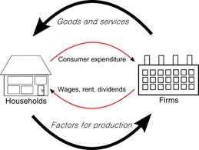
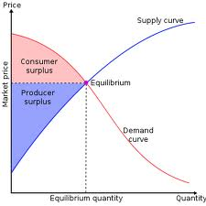

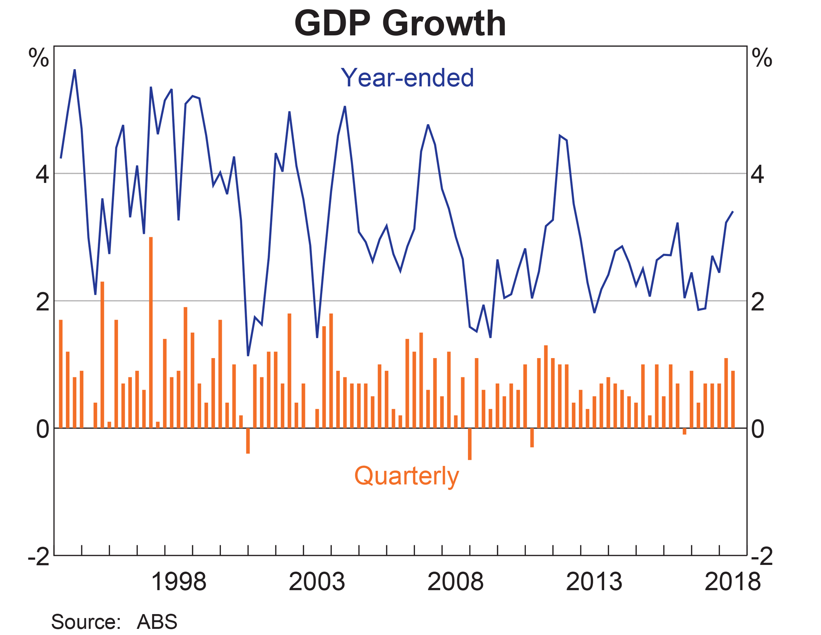
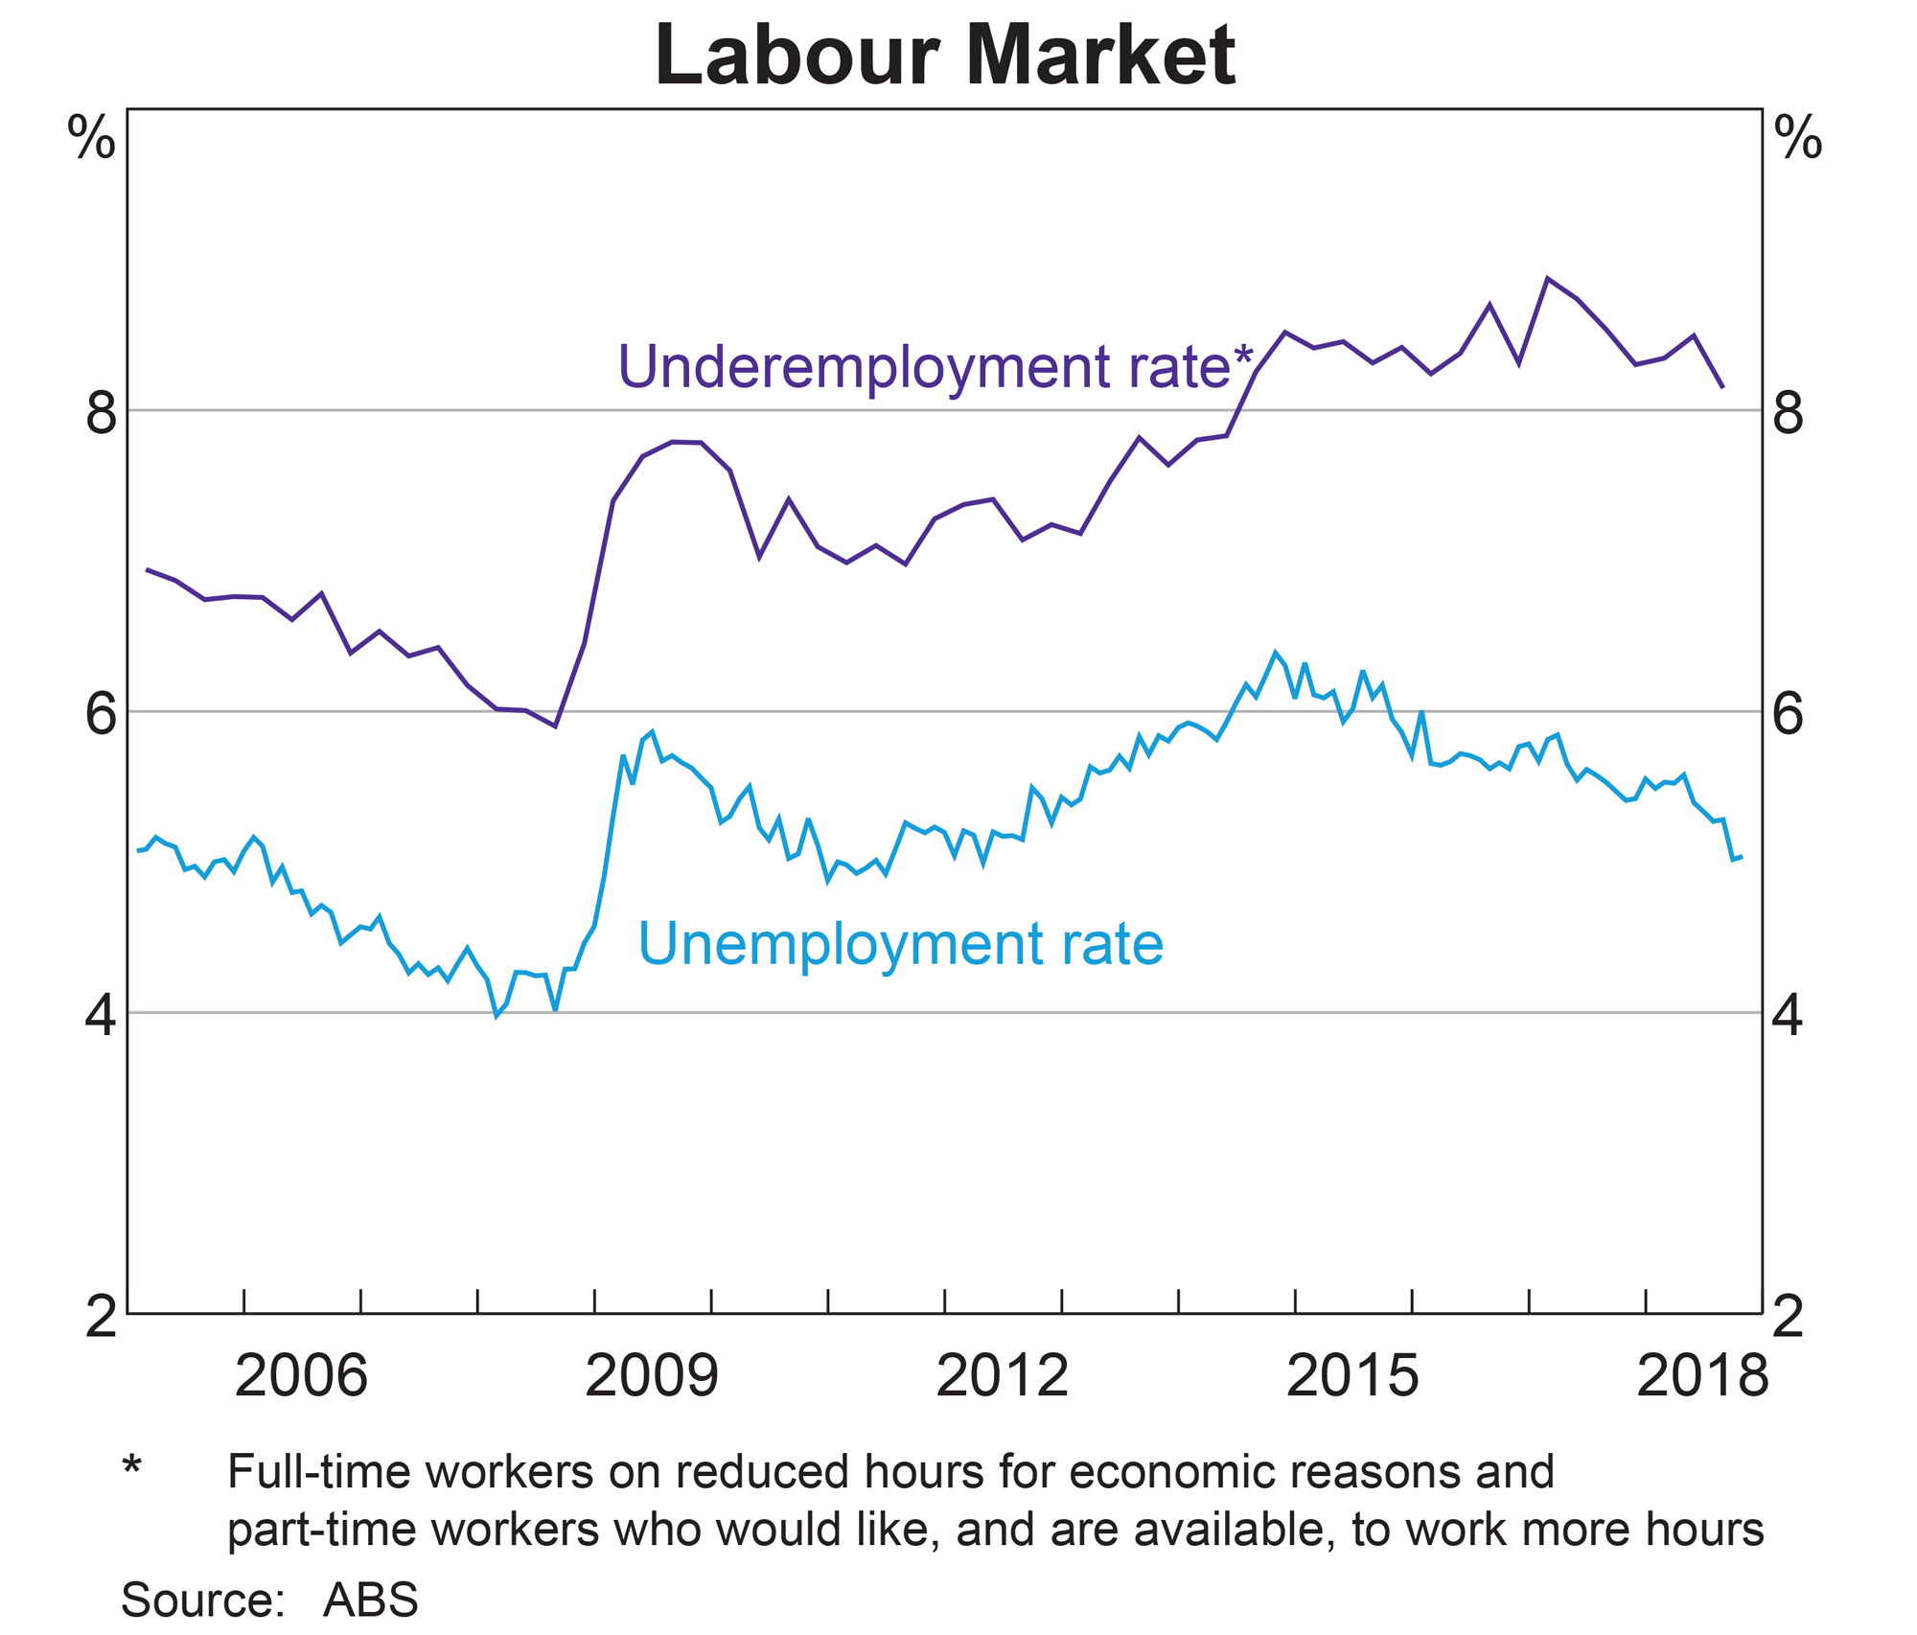

Assessment Outline: Economics Units 1 & 2 – Times of Assessment may vary with notice

Unit | When | Assessment Type | Assessment Tasks / Content | Raw Mark | Task Weighting  % | Outcome 1 Economic Inquiry | Outcome 2 Operation of the Economy | Outcome 3 Economic Policy and Action
1 | T1 Wk 4 | Data Interpretation | Markets, Supply and Demand Analysis | 24 | 10 | √ | √ | N/A
1 | T1 Wk 8 | Extended Answer | Elasticity, Efficiency and Equity | 20 | 10 | √ | √ | √
1 | T2 Wk 3 | Data Interpretation | Market failure | 24 | 10 | √ | √ | √
1 | T2 Wk 6/7 | EXAM | All of unit 1 | 100 | 12.5 | √ | √ | √
2 | T2 Wk 11 | Extended Answer | Macroeconomic Activity | 24 | 10 | √ | √ | √
2 | T3 Wk 3 | Data Interpretation | Macroeconomic Concepts and Issues | 20 | 10 | √ | √ | √
2 | T3 Wk 7 | Extended Answer | Macroeconomic Concepts and Issues | 24 | 10 | √ | √ | √
2 | T4 Wk 1 | Extended Answer | State of the Economy | 20 | 10 | √ | √ | √
1&2 | T4 Wk 3/4 | EXAM | Units 1 & 2 | 100 | 17.5 | √ | √ | √
 |  |  | TOTAL |  | 100%

Schools Curriculum and Standards Authority:
Data Interpretation 30%
Extended Answer 40%
Exam: 30%

COURSE OUTLINE - YEAR 11 2021 Unit 1

WEEKS | PROGRAM | EXTENDED DETAIL | Skills /  General Capabilities | ASSESSMENT
1 & 2  T1 | Markets, Demand, Supply and Equilibrium | - the characteristics of a market economy  - the distinction between product and factor markets  - the distinction between competitive and non‐competitive markets  - the law of demand  - the relationship between individual and market demand schedules and curves  - factors affecting demand  - price  - income  - population  - tastes and preferences  - prices of substitutes and complements  - expected future prices  - the effect of changes in price on quantity demanded i.e. expansion or contraction of demand  - the effect of changes in non-price factors on quantity demanded i.e. increase or decrease in demand  - the law of supply  - the relationship between individual and market supply schedules and curves factors affecting supply  - price  - costs of production  - factors of production  - expected future prices  - number of suppliers  - technology  - the effect of changes in price on quantity supplied i.e. expansion or contraction of supply  - the effect of changes in non-price factors on quantity supplied i.e. increase or decrease in supply | Study Skill: Mind-mapping  Literacy  Note Taking  Numeracy  Data Interpretation  Graphical Interpretation
WEEKS | PROGRAM | EXTENDED DETAIL | Skills /  General Capabilities | ASSESSMENT
- the concept of market equilibrium
- the effect of changes in demand and supply on market equilibrium
- the concepts of market clearing, shortages and surpluses
- how the price mechanism clears market surpluses and shortages
3 & 4  T1 | Elasticity | - the concept, and measurement, of price elasticity of demand  - determinants of price elasticity of demand  - the distinction between goods that are price elastic and price inelastic in demand  - the link between price elasticity of demand and total revenue  - the concept, and measurement, of income elasticity of demand  - the behaviour of normal goods and inferior goods in response to changes in income  - the concept of cross elasticity of demand  - the significance of substitute and complementary goods in relation to price, income and cross elasticity of demand  - the concept of price elasticity of supply  - the distinction between goods that are price elastic and price inelastic in supply  - determinants of price elasticity of supply  - the significance of price and income elasticity for consumers, business and government | Numeracy  Data Interpretation  Critical & Creative Thinking  Graphical Interpretation | Assessment 1  Data Interpretation  10%  Week 4
5 & 6  T1 | Efficiency & Equity | - the concept of efficiency  - the benefits to consumers as market participants, applying marginal benefit and consumer surplus  - the benefits to producers as market participants, applying marginal cost and producer surplus  - the efficiency of market equilibrium i.e. maximising total surplus  - the concept of equity (fairness)  - the relationship between equity and efficiency  - policy options to promote equity  - the distinction between price ceilings and price floors  - the effects of price celings and price floors on total surplus | Numeracy  Data Interpretation  Critical & Creative Thinking  Graphical Interpretation  Study Skill: Time Management (Research Essay)
WEEKS | PROGRAM | EXTENDED DETAIL | Skills /  General Capabilities | ASSESSMENT
7 & 8  T1 | Public Goods, Common Resources and Externalities | - the concept of market failure  - the distinction between public goods and common resources  - why public goods suffer from the free rider effect  - why common resources suffer from the tragedy of the commons  - policy options to reduce market failure associated with public goods and common resources  - the distinction between positive and negative externalities  - how an externality can influence market efficiency i.e. a deadweight loss  - policy options to correct for externalities, including the use of taxes and subsidies | Numeracy  Data Interpretation  Critical & Creative Thinking  Graphical Interpretation | Assessment 2  Extended Answer  10%  Week 8
9  T1 | Market Power | - the concept of market power  - the distinction between perfect and imperfect markets  - barriers to entry in a market  - how market power can influence market efficiency i.e. a deadweight loss  - the role of the Australian Competition and Consumer Commission (ACCC) in ensuring market efficiency  - policy options to influence market power, including regulation/deregulation and legislation | Ethical Understanding  Literacy
10 & 11  T2 W1-2 | Market failure and the Effects of Government Policies | - how under and overproduction in a market can result in a deadweight loss  - the effects of a tax on a market  the effects of a subsidy on a market |  | Assessment 3  Data Interpretation 10%  Term 2 Week 3
12 - 14  T2 (W3-5)  15 - 16  T2 (W6&7) | Exam Preparation &  Exam Weeks | Exam Preparation | How to revise  Mindmapping  Time Management

COURSE OUTLINE - YEAR 11 2021 – Unit 2
WEEKS | PROGRAM | EXTENDED DETAIL | Skills /  General Capabilities | ASSESSMENT
17  (T2 W8 ) | Macroeconomic Activity  Circular Flow of Income  &  Business Trade Cycle | - the concept of macroeconomics and its relevance  - the distinction between macroeconomics and microeconomics  - revise the concept of the circular flow of income  - the concepts of total spending, total output and total income and the relationship between them  - the concepts of equilibrium, leakages and injections in the circular flow of income  - the effect of changes in leakages and injections on the level of equilibrium in the circular flow of income model  - the concept of the business cycle  - the phases of the business cycle, and the characteristics of each phase  - indicators of economic activity  - leading indicators, including share prices, building loan approvals, new employment vacancies, business and consumer confidence, and stock/inventory levels  - coincident indicators, including retail sales, and new car registrations  - lagging indicators, including unemployment rates/levels and inflation rate | Numeracy  Data Interpretation  Critical & Creative Thinking  Graphical Interpretation
18  (T2 W9) | Aggregate Expenditure | - the components of aggregate expenditure  - consumption  - investment  - government spending  - net exports  - factors affecting each of the components of aggregate expenditure | Numeracy  Data Interpretation  Critical & Creative Thinking  Graphical Interpretation
WEEKS | PROGRAM | EXTENDED DETAIL | Skills /  General Capabilities | ASSESSMENT
19  (T2 Week 10 ) | Economic Growth | - the concept, and measurement, of economic growth  - the distinction between nominal gross domestic product (GDP), real GDP, and real GDP per capita  - GDP as a measure of economic growth  - determinants of economic growth  - the costs and benefits of economic growth | Numeracy  Data Interpretation  Critical & Creative Thinking  Graphical Interpretation | UNIT 2  Assessment 4  Extended Answer  10%  Term 2 Week 11
20  (T2 Week 11) | Inflation | - the concept, and measurement, of inflation  - the distinction between headline and underlying inflation  - the costs of inflation and the benefits of low inflation  - types of inflation  - demand pull  - cost push | Numeracy  Data Interpretation  Critical & Creative Thinking  Graphical Interpretation
21  (T3 W1) | Unemployment | - the concepts of unemployment, full employment, the natural rate of unemployment, the participation rate and underemployment  - the measurement of unemployment  - types and causes of unemployment, including cyclical, structural and frictional  - the effects of unemployment  - the implications of full employment for the economy  - the possible short-term trade-off between unemployment and inflatio | Data Interpretation  Critical & Creative Thinking  Ethical Understanding
22  (T3 W2 ) | Income Distribution | - the concepts of income and wealth  - how the Lorenz curve represents inequality in the distribution of income and wealth | Ethical Understanding | UNIT 2  Assessment 5  Data Interpretation  10%  Term 3 Week 3
WEEKS | PROGRAM | EXTENDED DETAIL | Skills /  General Capabilities | ASSESSMENT
23 & 24  (T3 Week 3&4) | The Public Sector | - the role of the government in a modified market economy  - regulation of business enterprises  - stabilising the business cycle  - redistributing income through taxation and spending  - the provision of goods and services  - the size of the government sector in the Australian economy currently, over time, and relative to other economies  - the size and composition of government revenue and spending in Australia at the Commonwealth, state and local government levels | Synthesising Information
25  (T3 W5 ) | Taxation | - the distinction between  - direct/indirect taxation  - progressive/regressive/proportional taxation  - taxes on income/expenditure  - types of Commonwealth taxes, including personal and income tax, goods and services tax, company tax, capital gains tax, fringe benefits tax, mineral resources rent tax, carbon tax and excise duty  - the concepts of equity, efficiency and simplicity in the context of Australia’s taxation system | Numeracy  Data Interpretation  Critical & Creative Thinking  Graphical Interpretation  Ethical Understanding
26  (T3 W6) | Macroeconomic performance and The Economic Objectives fo the Australian Government | - trends in, and influences on, Australia’s recent (the last ten years) economic performance using a range of economic indicators, including inflation, unemployment, economic growth and the current account balance  - the impact of recent (the last ten years) domestic and international events on the performance of the Australian economy  - the economic objectives of the Australian Government  - sustainable economic growth  - low unemployment (full employment)  - low inflation (price stability)  - a more equitable distribution of income  - the efficient allocation of resources | Synthesising Information
WEEKS | PROGRAM | EXTENDED DETAIL | Skills /  General Capabilities | ASSESSMENT
27 & 28  (T3 W 7&8) | Balance of Payments | - composition and direction of Australia’s trade  - the concept of the balance of payments  - the general structure of the current account, and the capital and financial account  - the distinction between the current account and the capital and financial account  - the relationship between the current account and the capital and financial account | Numeracy  Data Interpretation  Critical & Creative Thinking  Graphical Interpretation | UNIT 2  Assessment 6  Extended Answer  10%  Term 3 Week 7
29-32  (T3 W9-10)  (T4 W1-2) |  | Revision and Exam Preparation  Assessment Free Week (Week 2) | Study Skill: Time Management  How to revise  Mindmapping  Graphical Interpretation | UNIT 2  Assessment 7  Extended Answer  10%  Term 4 Week 1
33&34  (T4 W 3&4 ) | Exams

